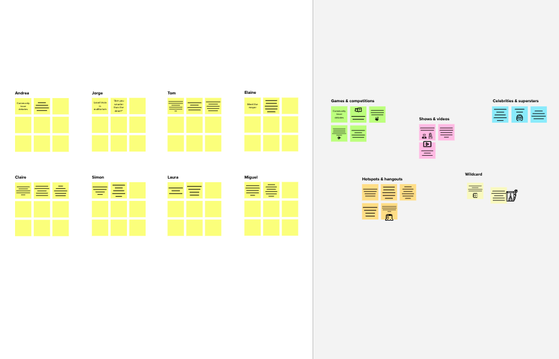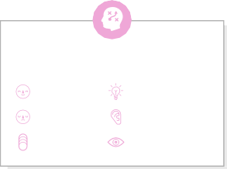

# Brainstorm

**TIP**

You can select a sticky note and hit the pencil [switch to sketch] icon to start drawing!

## Before you collaborate

### A little bit of preparation goes a long way with this session. Here’s what you need to do to get going.

#### 10 minutes

**1**

## Define your problem statement

### What problem are you trying to solve? Frame your problem as a How Might We statement. This will be the focus of your brainstorm.

#### 5 minutes

**2**

## Brainstorm

### Write down any ideas that come to mind that address your problem statement.

#### 10 minutes

**3**

## Group ideas

### Take turns sharing your ideas while clustering similar or related notes as you go. In the last 10 minutes, give each cluster a sentence-like label. If a cluster is bigger than six sticky notes, try and see if you and break it up into smaller sub-groups.

#### 20 minutes

**4**

## Prioritize

### Your team should all be on the same page about what's important moving forward. Place your ideas on this grid to determine which ideas are important and which are feasible.

**20 minutes**

## After you collaborate

You can export the mural as an image or pdf to share with members of your company who might find it helpful.

**Quick add-ons**

# & idea prioritization

**PROBLEM**

**How might we [your problem statement]?**

Use this template in your own brainstorming sessions so your team can unleash their imagination and start shaping concepts even if you're not sitting in the same room.

##### Team gathering

Define who should participate in the session and send an invite. Share relevant information or pre-work ahead.

##### Set the goal

Think about the problem you'll be focusing on solving in the brainstorming session.

##### Learn how to use the facilitation tools

Use the Facilitation Superpowers to run a happy and

**mohamed hashim**

Child are often told to keep something their friend or sibling did secret, but teach them that should they believe the activity was dangerous.

Child care safety protection have garnered bipartisan support.

Your child should know that no matter the circumstances, they should never let themselves be led away by a stranger.

By teaching basic contact information to your children.

Children should be able to share their full name, your name, address and a nearby landmark also familiar with a phone number.

Children are vulnerable to road accidents and injuries, especially if there is a lack of adult supervision.

Child start young on computers these days, and online safety lessons are a must.

**Mohamed riyas**

Care safety protection : Commonsense child care safety protection ensure that children are cared for in safe, high-quality care environment.

child care is a necessity for most working families, and millions of parents across the country rely on it each day.

Sates have the freedom to choose which child care providers are licensed in their state and may exempt certain categories of providers, such as relatives or faith-based providers, from licensure.

It is the state's role to decide the number of children that a child care provider's home can accommodate before the provider must become licensed.

**Hadhi sulaiman**

Child care safety protections have garnered bipartisan support.

States have also been making gradual progress toward improving child care standard.

Offer your assurance that should they share their secrets, you will try your very best not to make judgement.

Children also need to be careful to teach them that there are some circumstances where it's ok for people to touch them, such as in the doctor's office or school nurse if they are hurt at school.

**Rumaiz ahamed**

There are certain things that children should never play with, including matches, knives and any other dangerous weapons.

While you can try to keep things out of reach, it's important to teach children to respect that some things are only for adults and that they should leave them alone.

Teach your children never to give out information regarding what school they attend, where they live, hoe old they are ,or a phone number.

Keeping toy child safe at home is a top priority for any parent .

A child must know the safety rules at home because he will come under different circumstances.

It is important to know what you can do and what not.

**TIP**

Add customizable tags to sticky notes to make it easier to find, browse, organize, and categorize important ideas as themes within your mural.

Children must known

parents phone number.

Important that they know not to talk to strangers or go off with them without permission.

Children's are must know the Good touch and

Bad touch.

W e are safety

This should be an ongoing discussion with your child.

Therefore, licensing only covers a subset of providers and varies considerably from state to varies considerable from state to state.

Teaching your children about good touch and bad touch can help them determine when someone has behaved inappropriately with them.

The children's are safe at home.

1. **Share the mural**

**Share a view link** to the mural with stakeholders to keep them in the loop about the outcomes of the session.

##### Export the mural

Export a copy of the mural as a PNG or PDF to attach to emails, include in slides, or save in your drive.

**10 minutes** to prepare

**1 hour** to collaborate

**2-8 people** recommended

productive session.

[**Open article**](https://support.mural.co/en/articles/2113740-facilitation-superpowers)

**Key rules of brainstorming**

To run an smooth and productive session

**mirshad**

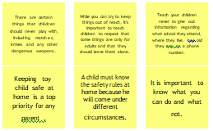

**Person 6**

##### Person 7

**Person 8**

here?

Report unsafe conditions.

Learn hoe to act in an Emergency.

## Keep moving forward

##### Strategy blueprint

Define the components of a new idea or strategy.

##### [Open the template](https://app.mural.co/template/e95f612a-f72a-4772-bc48-545aaa04e0c9/984865a6-0a96-4472-a48d-47639307b3ca)

**Customer experience journey map**

Stay in topic. Defer judgment.

Encourage wild ideas. Listen to others.

## Importance

If each of these

Understand customer needs, motivations, and obstacles for an experience.

[**Open the template**](https://app.mural.co/template/b7114010-3a67-4d63-a51d-6f2cedc9633f/c1b465ab-57af-4624-8faf-ebb312edc0eb)

Most of children affected by internet. that the way the children can kidnaped.

Go for volume. If possible, be visual.

tasks could get

done without any difficulty or cost, which would have the most positive impact?

##### Strengths, weaknesses, opportunities & threats

Identify strengths, weaknesses, opportunities, and threats (SWOT) to develop a plan.

##### [Open the template](https://app.mural.co/template/6a062671-89ee-4b76-9409-2603d8b098be/ca270343-1d54-4952-9d8c-fbc303ffd0f2)

###### TIP

Participants can use their cursors to point at where sticky notes should go on the grid. The facilitator can confirm the spot by using the laser pointer holding the **H key** on the keyboard.

##### [Share template feedback](https://muralco.typeform.com/to/CiqaHVat?typeform-source=app.mural.co)

[**Share template feedback**](https://muralco.typeform.com/to/CiqaHVat?typeform-source=app.mural.co)

## Feasibility

Regardless of their importance, which tasks are more feasible than others? (Cost, time, effort, complexity, etc.)

**Template**

**Need some inspiration?**

See a finished version of this template to kickstart your work.

[**Open example**](https://app.mural.co/template/e5a93b7b-49f2-48c9-afd7-a635d860eba6/93f1b98d-b2d2-4695-8e85-7e9c0d2fd9b9)